1. **Hướng dẫn cài đặt PostgreSQL Server 15**
2. Chạy file setup:

1. Bấm Next

1. Chọn thư mục chứa phần mềm, ấn Next

1. Tích chọn như hình, ấn next

1. Chọn thư mục chứa Data, ấn Next

1. Đặt mật khẩu cho PostgreSql, ấn Next

1. Cài đật cổng chạy phần mềm, ấn Next

1. Chọn ngôn ngữ, ấn Next

1. Ấn Next

1. Ấn Next

1. Chờ phần mềm chạy xong,

1. Ấn Finish

1. Chọn Instance PostgreSQL, ấn Next

1. Tích chọn PostGIS 3.3, ấn Next

1. Ấn Next

1. Ấn Next

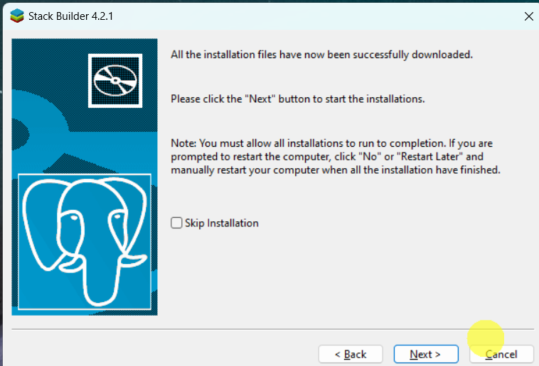

1. I Agree

1. Ấn Next

1. Chọn thư mục lưu, ấn Next

1. Finish

